All mosquito traps from summer 2017. Abundance standardized for time (3.5 hours)

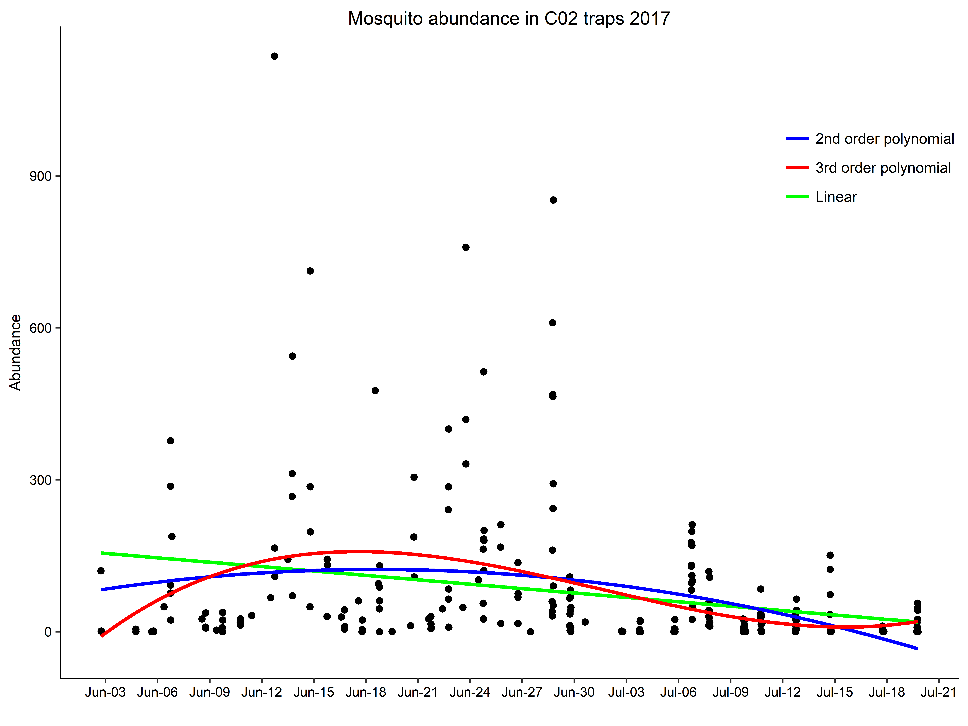

> aictable(rawaic,nR)

Params logL AICc deltaAICc weight cumwt

polynomial3 5 -1610.287 3230.815 0.000 0.9781 0.9781

polynomial2 4 -1615.163 3238.486 7.671 0.0211 0.9992

linear 3 -1619.477 3245.051 14.236 0.0008 1.0000

null 2 -1627.648 3259.344 28.529 0.0000 1.0000

Count data follow a zero inflated neg binomial distribution (second best neg. binomial)

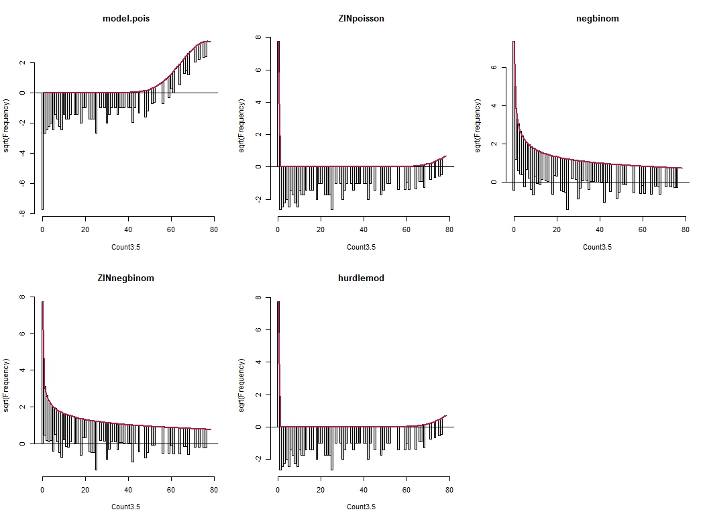

aictable(rawaic,nR)

Params logL AICc deltaAICc weight cumwt

ZINnegbinom 3 -1196.255 2398.605 0.0000 0.88 0.88

negbinom 2 -1199.271 2402.591 3.9856 0.12 1.00

null 2 -1627.648 3259.344 860.7390 0.00 1.00

hurdlemod 2 -16426.906 32857.859 30459.2542 0.00 1.00

ZINpoisson 2 -16426.906 32857.859 30459.2542 0.00 1.00

model.pois 1 -21582.176 43166.367 40767.7620 0.00 1.00

Extracted weather data from weather stations during trapping times.

Frequency histograms of weather variables during trapping times

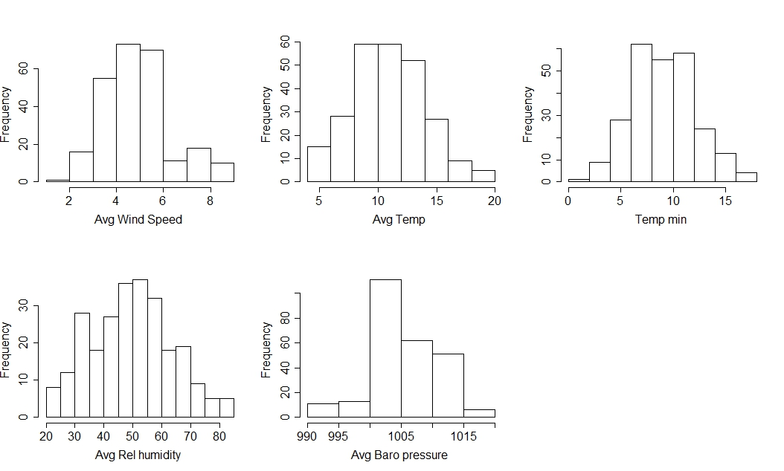

Correlations between weather variables (RH and temp are correlated, everything else looks okay)

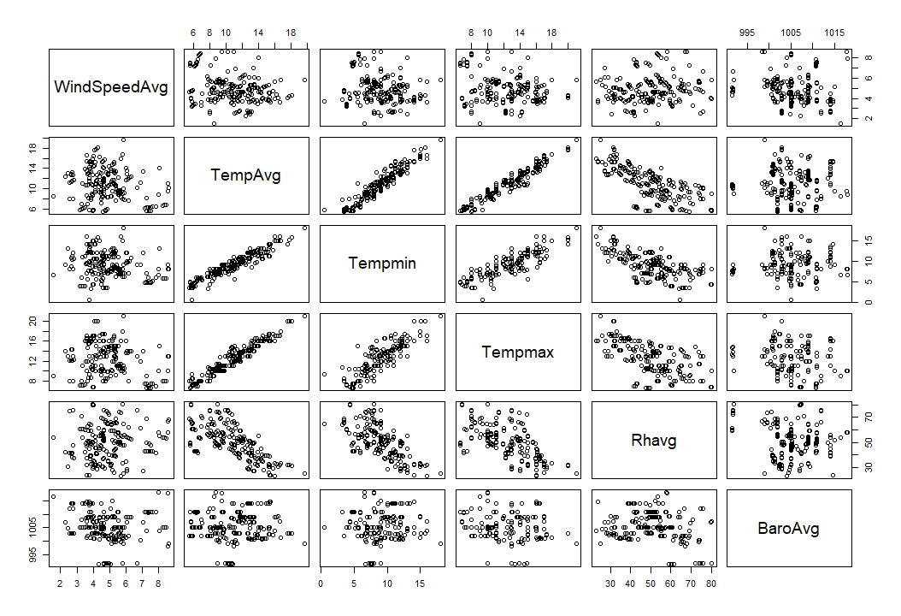

Mosquito abundance by weather variables

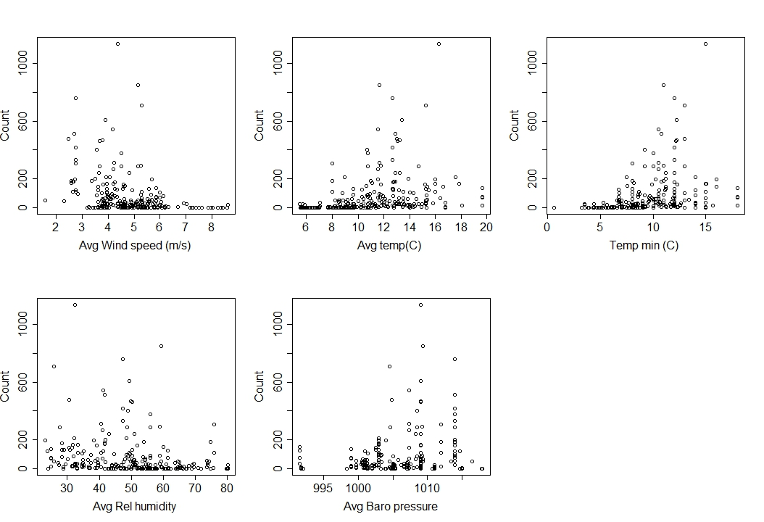

Residuals (from the polynomial on graph 1) by weather variables *(note these graphs are almost identical to the ones above)

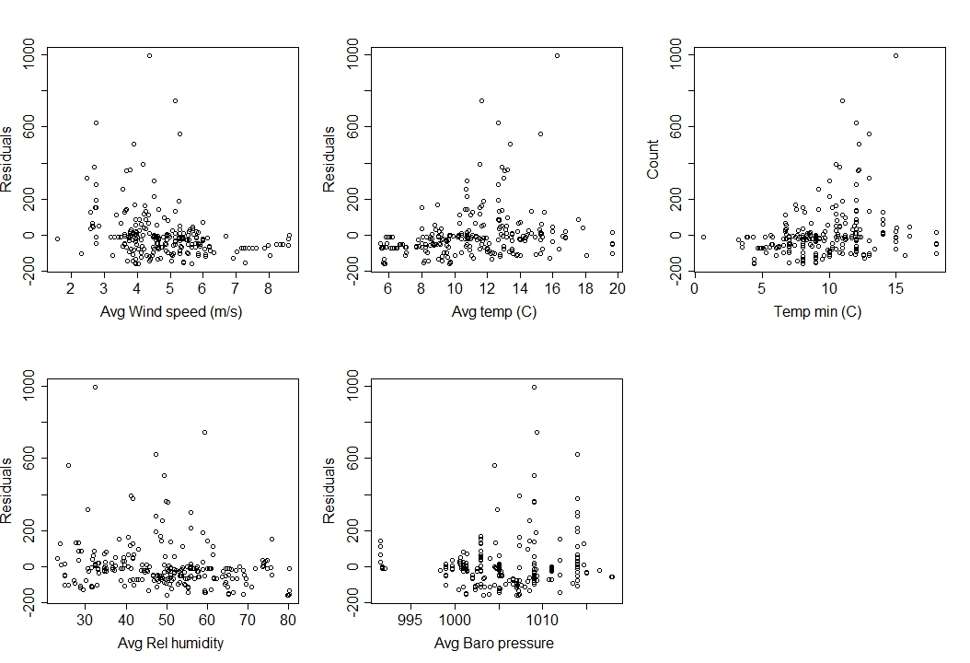

Compared models predicting mosquito abundance w/ ZIN binomial dist. Using AIC using diff combinations of date and weather variables as predictor **So far I can only test for linear relationships, keep getting an error when I try and make something quadratic

Min temp, Date, and Wind are best predictors of mosquito abundance

> aictable(rawaic,nR)

Params logL AICc deltaAICc weight cumwt

MinTempDateWind 9 -1105.393 2229.524 0.0000 0.6555 0.6555

MinTempDateWindBaro 11 -1104.154 2231.399 1.8745 0.2568 0.9123

MinTempWind 7 -1109.691 2233.838 4.3141 0.0758 0.9881

TempDateWind 9 -1109.909 2238.556 9.0316 0.0072 0.9953

TempDateWindBaro 11 -1108.154 2239.399 9.8749 0.0047 1.0000

TempRHWind 9 -1117.090 2252.918 23.3941 0.0000 1.0000

TempDate 7 -1142.672 2299.800 70.2755 0.0000 1.0000

MinTemp 5 -1146.571 2303.385 73.8606 0.0000 1.0000

TempAvg 5 -1152.550 2315.341 85.8169 0.0000 1.0000

Wind 5 -1154.394 2319.030 89.5054 0.0000 1.0000

MinTempDate 7 -1155.306 2325.067 95.5425 0.0000 1.0000

lineardate 5 -1181.876 2373.994 144.4702 0.0000 1.0000

RhAvg 5 -1185.950 2382.142 152.6175 0.0000 1.0000

BaroAvg 5 -1187.420 2385.081 155.5570 0.0000 1.0000

null 3 -1196.255 2398.605 169.0808 0.0000 1.0000

But I get a weird model output….

Call:

zeroinfl(formula = Count3.5 ~ Tempmin + Datetime_Start + WindSpeedAvg, data = C02weathertraptime,

dist = "negbin")

Pearson residuals:

Min 1Q Median 3Q Max

-0.8292 -0.6086 -0.3773 0.1171 10.0597

Count model coefficients (negbin with log link):

Estimate Std. Error z value Pr(>|z|)

(Intercept) -1.471e+04 NA NA NA

Tempmin 1.777e-01 NA NA NA

Datetime_Start -2.387e-07 NA NA NA

WindSpeedAvg -4.724e-01 NA NA NA

Log(theta) -3.665e-01 NA NA NA

Zero-inflation model coefficients (binomial with logit link):

Estimate Std. Error z value Pr(>|z|)

(Intercept) 1.475e+04 NA NA NA

Tempmin -7.259e-01 NA NA NA

Datetime_Start 2.394e-07 NA NA NA

WindSpeedAvg 9.727e-01 NA NA NA

Theta = 0.6931

Number of iterations in BFGS optimization: 19

Log-likelihood: -1105 on 9 Df

Same results with a neg binomial distribution (not zero inflated)

> aictable(rawaic,nR)

Params logL AICc deltaAICc weight cumwt

MinTempDateWindBaro1 6 -1136.712 2285.764 0.0000 0.6647 0.6647

MinTempDateWind1 5 -1139.237 2288.716 2.9520 0.1519 0.8166

MinTempWind1 4 -1140.441 2289.042 3.2777 0.1291 0.9457

TempRHWind1 5 -1140.582 2291.405 5.6409 0.0396 0.9853

TempDateWind1 5 -1142.018 2294.277 8.5129 0.0094 0.9948

TempDateWindBaro1 6 -1141.556 2295.453 9.6885 0.0052 1.0000

MinTempDate1 4 -1166.852 2341.866 56.1013 0.0000 1.0000

MinTemp1 3 -1170.938 2347.971 62.2066 0.0000 1.0000

TempDate1 4 -1169.972 2348.104 62.3396 0.0000 1.0000

Wind1 3 -1172.154 2350.404 64.6392 0.0000 1.0000

TempAvg1 3 -1179.476 2365.048 79.2834 0.0000 1.0000

lineardate1 3 -1186.035 2378.165 92.4011 0.0000 1.0000

RhAvg1 3 -1193.468 2393.032 107.2672 0.0000 1.0000

BaroAvg1 3 -1193.580 2393.256 107.4921 0.0000 1.0000

null1 2 -1199.271 2402.591 116.8263 0.0000 1.0000

And results are more satisfying

> summary(MinTempDateWindBaro1)

Call:

glm.nb(formula = Count3.5 ~ Tempmin + Datetime_Start + WindSpeedAvg +

BaroAvg, data = C02weathertraptime, init.theta = 0.4387478689,

link = log)

Deviance Residuals:

Min 1Q Median 3Q Max

-2.2080 -1.1354 -0.6418 0.0478 3.5187

Coefficients:

Estimate Std. Error z value Pr(>|z|)

(Intercept) -1.855e+04 6.711e+03 -2.764 0.00572 **

Tempmin 3.226e-01 3.258e-02 9.903 < 2e-16 ***

Datetime_Start -3.019e-07 1.091e-07 -2.767 0.00566 **

WindSpeedAvg -7.218e-01 7.454e-02 -9.683 < 2e-16 ***

BaroAvg -5.194e-02 2.155e-02 -2.410 0.01597 *

---

Signif. codes: 0 ‘***’ 0.001 ‘**’ 0.01 ‘*’ 0.05 ‘.’ 0.1 ‘ ’ 1

(Dispersion parameter for Negative Binomial(0.4387) family taken to be 1)

Null deviance: 453.44 on 253 degrees of freedom

Residual deviance: 294.32 on 249 degrees of freedom

AIC: 2285.4

Number of Fisher Scoring iterations: 1

Theta: 0.4387

Std. Err.: 0.0399

Tested for linear vs. quadratic relationships with count vs. weather variables

(*Used a subset of data, eliminated Avg wind > 6.5, Avg temp <8, min temp < 6)

Models:

Windlinear<-glm.nb(Count3.5 ~ WindSpeedAvg, data=C02weathertraptimesubset2)

Windquad<-glm.nb(Count3.5 ~ WindSpeedAvg + I(WindSpeedAvg^2), data=C02weathertraptimesubset2)

Templinear<-glm.nb(Count3.5 ~ TempAvg, data=C02weathertraptimesubset2)

Tempquad<-glm.nb(Count3.5 ~ TempAvg + I(TempAvg^2), data=C02weathertraptimesubset2)

Tempminlinear<-glm.nb(Count3.5 ~ Tempmin, data=C02weathertraptimesubset2)

Tempminquad<-glm.nb(Count3.5 ~ Tempmin + I(Tempmin^2), data=C02weathertraptimesubset2)

Tempmaxlinear<-glm.nb(Count3.5 ~ Tempmax, data=C02weathertraptimesubset2)

Tempmaxquad<-glm.nb(Count3.5 ~ Tempmax + I(Tempmax^2), data=C02weathertraptimesubset2)

Rhlinear<-glm.nb(Count3.5 ~ Rhavg, data=C02weathertraptimesubset2)

Rhquad<-glm.nb(Count3.5 ~ Rhavg + I(Rhavg^2), data=C02weathertraptimesubset2)

Barolinear<-glm.nb(Count3.5 ~ BaroAvg, data=C02weathertraptimesubset2)

Baroquad<-glm.nb(Count3.5 ~ BaroAvg + I(BaroAvg^2), data=C02weathertraptimesubset2)

> aictable(rawaic,nR)

Params logL AICc deltaAICc weight cumwt

**Tempminquad** 4 -1012.506 2033.224 0.0000 0.8841 0.8841

**Tempquad** 4 -1014.984 2038.180 4.9565 0.0742 0.9583

Tempminlinear 3 -1017.364 2040.855 7.6307 0.0195 0.9778

**Windlinear** 3 -1017.652 2041.432 8.2078 0.0146 0.9923

Windquad 4 -1017.409 2043.030 9.8058 0.0066 0.9989

**Barolinear** 3 -1020.826 2047.779 14.5550 0.0006 0.9995

Baroquad 4 -1020.759 2049.730 16.5064 0.0002 0.9998

**Rhquad** 4 -1021.376 2050.965 17.7415 0.0001 0.9999

Templinear 3 -1022.884 2051.894 18.6700 0.0001 1.0000

**Tempmaxquad** 4 -1022.593 2053.398 20.1744 0.0000 1.0000

Rhlinear 3 -1025.297 2056.720 23.4964 0.0000 1.0000

Tempmaxlinear 3 -1026.630 2059.387 26.1630 0.0000 1.0000

Date as linear, quadratic, 3rd order poly

C02weathertraptimesubset2$Date.jul <- format(C02weathertraptimesubset2$Datetime_Start, "%j")

C02weathertraptimesubset2$Date.num<-as.numeric(C02weathertraptimesubset2$Date.jul)

Timelinear<-glm.nb(Count3.5 ~ Date.num, data=C02weathertraptimesubset2)

Timequad2<-glm.nb(Count3.5 ~ Date.num + I(Date.num^2), data=C02weathertraptimesubset2)

Timequad3<-glm.nb(Count3.5 ~ Date.num + I(Date.num^2) +I(Date.num^3) , data=C02weathertraptimesubset2)

rawaic<-AIC(Timelinear, Timequad2, Timequad3)

nR<-dim(C02weathertraptimesubset2)[1] #Sample size

aictable(rawaic,nR)

> aictable(rawaic,nR)

Params logL AICc deltaAICc weight cumwt

**Timequad3 5 -1005.636 2021.592 0.0000 0.7676 0.7676**

Timequad2 4 -1007.887 2023.986 2.3938 0.2319 0.9995

Timelinear 3 -1015.124 2036.376 14.7831 0.0005 1.0000

Full model results

> summary(fullmodel)

Call:

glm.nb(formula = Count3.5 ~ Date.num + I(Date.num^2) + I(Date.num^3) +

Tempmin + I(Tempmin^2) + WindSpeedAvg + BaroAvg + Rhavg +

I(Rhavg^2), data = C02weathertraptimesubset2, init.theta = 0.6375665884,

link = log)

Deviance Residuals:

Min 1Q Median 3Q Max

-2.4866 -1.1307 -0.5369 0.2485 2.4545

Coefficients:

Estimate Std. Error z value Pr(>|z|)

(Intercept) -5.882e+02 2.930e+02 -2.007 0.044716 *

Date.num 1.099e+01 4.857e+00 2.262 0.023672 *

I(Date.num^2) -6.038e-02 2.751e-02 -2.195 0.028187 *

I(Date.num^3) 1.097e-04 5.183e-05 2.116 0.034350 *

Tempmin 9.543e-01 2.679e-01 3.562 0.000367 ***

I(Tempmin^2) -3.144e-02 1.154e-02 -2.725 0.006436 **

WindSpeedAvg -6.591e-01 1.096e-01 -6.016 1.79e-09 ***

BaroAvg -7.231e-02 2.587e-02 -2.795 0.005186 **

Rhavg -1.704e-03 6.615e-02 -0.026 0.979450

I(Rhavg^2) 4.071e-04 6.421e-04 0.634 0.526110

---

Signif. codes: 0 ‘***’ 0.001 ‘**’ 0.01 ‘*’ 0.05 ‘.’ 0.1 ‘ ’ 1

(Dispersion parameter for Negative Binomial(0.6376) family taken to be 1)

Null deviance: 334.27 on 192 degrees of freedom

Residual deviance: 232.63 on 183 degrees of freedom

AIC: 1996

Number of Fisher Scoring iterations: 1

Theta: 0.6376

Std. Err.: 0.0618